ASN.1 Editor

Introduction:
ASN.1* DER** encoded data is widely used in digital security protocols. The encoded data is not readable by regular text editor. The ASN.1 Editor is designed to allow user to view and modify the encoded data easily.
Note: This editor doesn’t do any data verification and schema checking. The user needs to make sure the edited data conform to certain constrains.
* ASN.1: Abstract Syntax Notation One
** DER: Distinguished Encoding Rules
Main View:
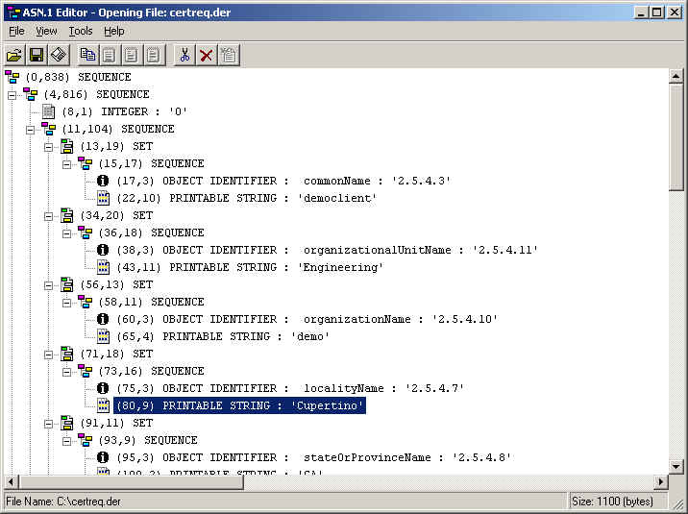

Main Features:

1. Dump text data:
You can view the selected node branch text dump by right click the designated node and select “View Node Text”.
Text Viewer:
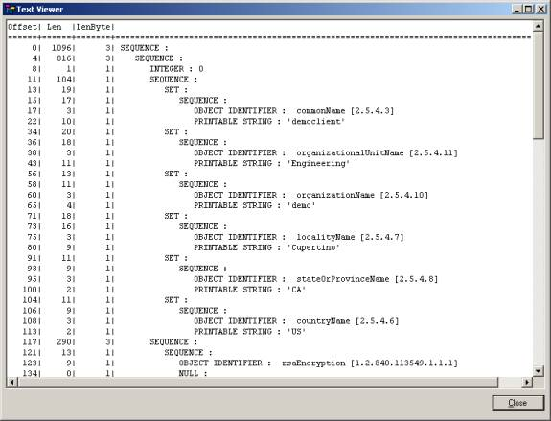

2. Atomically Parse “encapsulates” data
OCTET and BITSTRING may encapsulates DER encoded data, for example:
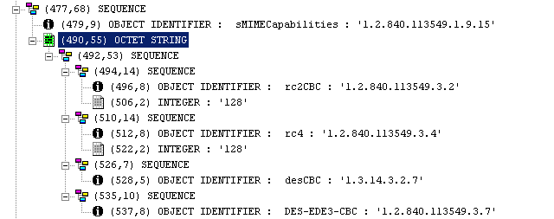
ASN.1 Editor can automatically parse the data structure.

3. Hex Data Viewer
Click: View->Hex Viewer, you can view the binary data structure.
Hex Viewer:
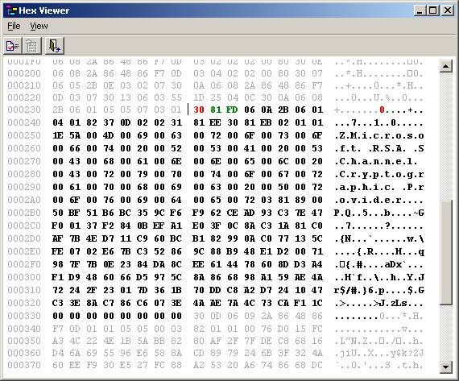

4. Extensible OID table
OID.txt file is installed in the same directory as Asn1Editor.EXE.
Here is the sample records:
0.9.2342.19200300.100.1.25, domainComponent
1.2.36.68980861.1.1.10, Signet pilot
1.2.36.68980861.1.1.11, Signet intraNet
1.2.36.68980861.1.1.2, Signet personal
1.2.36.68980861.1.1.20, Signet securityPolicy
OID and the description are comma separated. It can be extend in order to add in additional OIDs.

5. Change node content
Double click the selected node you can see the "Node Content Editor".
Node Content Editor:
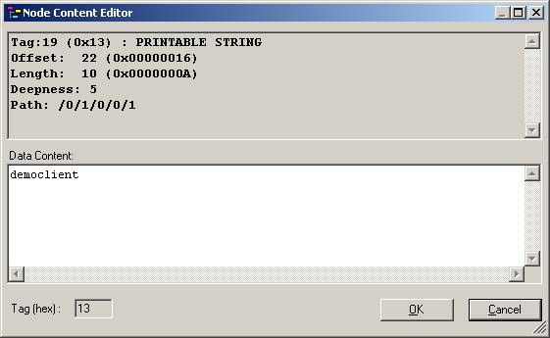

6. Save selected node data
You can save designated node data into a file by right click the node and select "Save selected node as...".

7. Copy selected node data into clipboard
Right click the node and select "Copy".

8. Paste node from clipboard
Right click the insert point node and select "Paste as last child node", "Paste before current node", or "Paste after current node" to perform the insert operation.

9. Binary/Hex/Base64 data converter
Converting the data format between Hex, Base64, and PEM by the "Data Converter".
Data Converter:
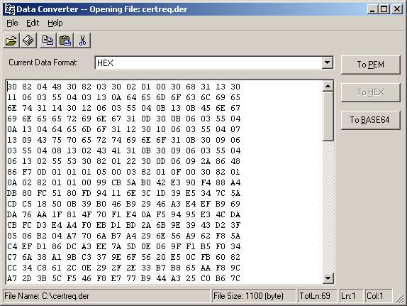

Liping Dai
August 2003

